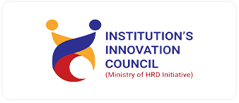
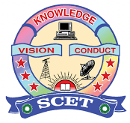
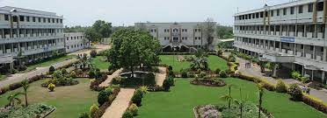
SWARNANDHRA
(Autonomous)
COLLEGE OF ENGINEERING AND TECHNOLOGY
Seetharampuram, Narsapur.

Sciences and Humanities

Report on Legal Awareness Programme on Implementation of

NALSA( DAWN)- SCHEME, 2025

Drug Awaareness and Wellness Navigation for a

DRUG FREE INDIA
SocialMedia
Facebook | Swarnandhra Autonomous
YouTube | SCET -IQAC

AcademicYear | 2025-2026
Programdriven by | Sciences and Humanities Department
Quarter | I/II/III/IV
Title of the Program | NALSA( DAWN)- SCHEME, 2025; Drug Awaareness and Wellness Navigation for a DRUG FREE INDIA
ProgrammeType | Level -1 Expert Talk/Mentoring session/ Exposure visit  Level -2 Conference/Competition/ Workshop/Seminar/ Exposure visit  Level -3 Workshop/Bootcamp/Exhibition/Demoplay/Competitions/Hackathons  Level -4 Workshop/Bootcamp/Exhibition/TechFest/Competitions/Hackathons
ProgrammeTheme/Thrust area | Q1-Inspiration/Motivation/Ideation  Q2 –Idea/innovation validation and concept development  Q3- Prototype/Design/Process development for Business  Q4- awareness about startup and related ecosystem
ProgramStatsDate | 25/10/2025
ProgramEndingDate | 25/10/2025
NumberofStudentsParticipants | 400
Numberof FacultyParticipants | 30
NumberofExpert Participants | 10
Expenditure, If Any
Mode ofDelivery | Online/Offline
Program Objectives | The NALSA (DAWN - Drug Awareness and Wellness Navigation - For a Drug Free India) Scheme, 2025, adopts a comprehensive approach by establishing of units at district level to ensure access to justice, spread legal awareness and support victims of drug abuse, thereby paving the way for a healthier, safer and drug-free

Benefits in terms oflearning/skill/knowledgedevelopment | . The NALSA (DAWN - Drug Awareness and Wellness Navigation) Scheme, 2025, focuses on a three-pronged approach to combat drug abuse in India: prevention through awareness, access to justice for victims, and support for rehabilitation. The program addresses the drug menace from both a legal and wellness perspective, providing benefits to multiple segments of society
ProgramCoordinator(S) | Dr. ZEHRABI

Programm/ Event Report

Swarnandhra College of Engineering and Technology, Department of Basic Sciences & Humanities, organized a program on **Drug Awareness and Wellness Navigation for a Drug-Free India** in the seminar hall. The esteemed Civil Judge (Senior Division) of Narsapur, Sri G. Ganga Raju, delivered an insightful session aimed at raising awareness about the dangers of drug addiction.The event was further enriched by the presence of several distinguished speakers:
Sri Ch. Danayya Naidu, Advocate, Narsapuram
Sri Y. Devendra Phanikar, Advocate, Narsapuram
Sri Y. Satish Kumar, Social Worker, Narsapuram
Sri V. Surya Prakash Rao, General Secretary, Bar Association, Narsapuram
Sri B. Durga Prasad, Inspector of Police, Narsapuram Rural Circle
Each of these experts addressed various aspects of drug addiction and its negative impacts on individuals and society, emphasizing the importance of prevention and rehabilitation.The program was coordinated by Dr. Zehrabi, and saw the active participation of 30 faculty members and over 400 students, all of whom benefited from the invaluable insights shared during the event.

.
Event Photo
